
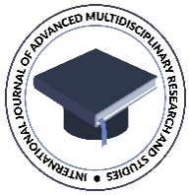
OPRA Publications
Volume 6, Issue 4, 2024
International Journal of Advanced Multidisciplinary Research and Studies
Peer-Reviewed Journal
E ISSN: 2583-049X

